Year 12 General Human Biology
Immunity

Task 3: Control of Infectious Diseases

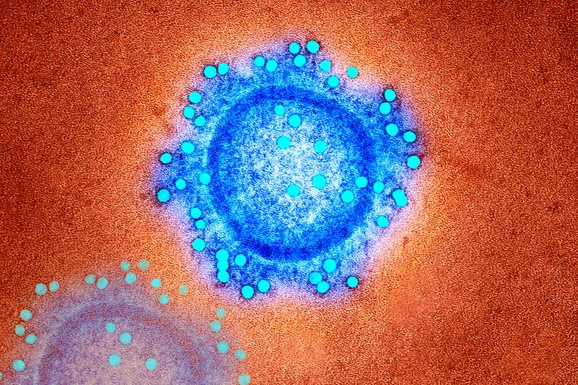
Logbook
General

Name: __________________________________
Teacher: Mrs Cunningham

Contents Page
Page # | Description

CHECK POINTS

☐ | Week 11 | Select issue and identify relevant scientific concepts for research
☐ | Week 11 | Identify sources and conduct research
☐ | Week 12 | Submit draft article for feedback
☐ | Week 12 | Submit final article

Authentication strategies:
The teacher will:
- provide class time for task completion.
- monitor progress at specified check points.
- collect and annotate drafts.

The student will:
- maintain a logbook / journal to document their progress.
- acknowledge all sources.

Claim options:

Claim 1: Immunisation is the safest and most effective way to develop herd immunity
National Immunisation Program Schedule
https://www.health.gov.au/topics/immunisation/when-to-get-vaccinated/national-immunisation-program-schedule
Claim 2: Antibiotic resistance is a global concern
https://www.who.int/news-room/fact-sheets/detail/antimicrobial-resistance
Part A: Background Research
Chosen claim option:
____________________________________________________________________________________________________________________________________________________________________________________
Reason for selecting the above claim option:
____________________________________________________________________________________________________________________________________________________________________________________________________________________________________________________________________________________________________________________________________________________________________________________________________________________________________Research questions you need to ask yourself:
________________________________________________________________________________________________________________________________________________________________________________________________________________________________________________________________________________________________________________________________________________________________________________________________________________________________________________________________________________________________________________________________________________________________________________________________________________________________________________________________________________________________________________________________________________________________________________________________________________________________________________________________________
Reliable source 1 information to answer research questions (use the one provided)
____________________________________________________________________________________________________________________________________________________________________________________________________________________________________________________________________________________________________________________________________________________________________________________________________________________________________________________________________________________________________________________________________________________________________________________________________________________________________________________________________________________________________________________________________________________________________________________________________________________________________________________________________________________________________________________________________
________________________________________________________________________________________________________________________________________________________________________________________________________________________________________________________________________________________________________________________________________________________________________________________________________________________________________________________________________________________________________________________________________________________________________________________________________________________________________________________________________________________________________________________________________________
Reference for reliable source 1 (the one provided):
________________________________________________________________________________________________________________________________________________________________________________________________________________________________________________
Reliable source 2 information to answer research questions (you need to find another one yourself to use to gather information):
____________________________________________________________________________________________________________________________________________________________________________________________________________________________________________________________________________________________________________________________________________________________________________________________________________________________________________________________________________________________________________________________________________________________________________________________________________________________________________________________________________________________________________________________________________________________________________________________________________________________________________________________________________________________________________________________________
________________________________________________________________________________________________________________________________________________________________________________________________________________________________________________________________________________________________________________________________________________________________________________________________________________________________________________________________________________________________________________________________________________________________________________________________________________________________________________________________________________________________________________________________________________________________________________________________________________________________________________________________________
Reference for reliable source 2 (the one you found yourself to gather information):
________________________________________________________________________________________________________________________________________________________________________________________________________________________________________________
Research the chosen claim option related to the immune system:
________________________________________________________________________________________________________________________________________________________________________________________________________________________________________________________________________________________________________________________________________________________________________________________________________________________________________________________________________________________________________________________________________________________________________________________________________________________________________________________________________________________________________________________________________________________________________________________________________________________________________________________________________________________________________________________________________________________________________________________________________________________________________________________________________________________________________________________________________________________________________________________________________________________________________________________________________________________________________________________________________________________________________________________________________________________________________________________________________________________________________________________________________________________________________________________________________________________________________________________________________________________________________________________________________________________________________________________________________________________________________________________________________________________________________________________________________________________________________________________________________________________________________________________________________________________________________________________________________________________________________________________________________________________________________________________________________________________________________________________________________________________________________________________________________________________________________________________________________________________________________________________________________________________________________________________________________________________________________________________________________________________________________________________________________________________________________________________________________________________________________________________________________________________________________________________________________________________________________________________________________________________________________________________________________________________________________________________________________________________________________________________________________________________________________________________________________________________________________________________________________________________________________________________________________________________________________________________________________________________________________________________________________________________________________________________________________________________________________________________________________________________________________________________________________________________________________________________________________________________________________________________________________________________________________________________________________________________________________________________________________________________________________________________________________________________________________________________________________________________________________________________________________________________________________________________________________________________________________________________________________________________________________________________________________________________________________________________________________________________________________________________________________________________________________________________________________________________________________________________________________________________________________________________________________________________________________________________________________________________________________________________________________________________________________________________________________________________________________________________________________________________________________________________________________________________________________________________________________________________________________________________________________________________________________________________________________________________________________________________________________________________________________________________________________________________________________________________________________________________________________________________________________________________________________________________________________________________________________________________________________________________________________________________________________________________________________________________________________________________________________________________________________________________________________________________________________________________________________________________________________________________________________________________________________________________________________________________Research the relevant scientific concepts associated with the claim chosen:
____________________________________________________________________________________________________________________________________________________________________________________________________________________________________________________________________________________________________________________________________________________________________________________________________________________________________________________________________________________________________________________________________________________________________________________________________________________________________________________________________________________
________________________________________________________________________________________________________________________________________________________________________________________________________________________________________________________________________________________________________________________________________________________________________________________________________________________________________________________________________________________________________________________________________________________________________________________________________________________________________________________________________________________________________________________________________________________________________________________________________________________________________________________________________________________________________________________________________________________________________________________________________________________________________________________________________________________________________________________________________________________________________________________________________________________________________________________________________________________________________________________________________________________________________________________________________________________________________________________________________________________________________________________________________________________________________________________________________________________________________________________________________________________________________________________________________________________________________________________________________________________________________________________________________________________________________________________________________________________________________________________________________________________________________________________________________________________________________________________________________________________________________________________________________________________________________________________________________________________________________________________________________________________________________________________________________________________________________________________________________________________________________________________________________________________________________________________________________________________________________________________________________________________________________________________________________________
Research the impact of the claim on individuals.
____________________________________________________________________________________________________________________________________________________________________________________________________________________________________________________________________________________________________________________________________________________________________________________________________________________________________________________________________________________________________________________________________________________________________________________________________________________________________________________________________________________________________________________________________________________________________________________________________________________________________________________________________________________________________________________________________________________________________________________________________________________________________________________________________________________________________________________________________________________________________________________________________________________________________________________________________________________________________________________________________________________________________________________________________________________________________________________________________________________________________________________________________________________________________________________________________________________________________________________________________________________________________________________________________________________________________________________________________________________________________________________________________________________________________________________________________________________________________________________________________________________________________________________________________________________________________________________________________________________________________________________________________________________________________________________________________________________________________________________________________________________________________________________________________________________________________________________________________________________________________________________________________________________________________________________________________________________________________________________________________________________________________________________________________________________________________________________________________________________________________________________________________________________________________________________________________________________________________________________________________________________________________________________________
Research any impacts the claim may have on society:
____________________________________________________________________________________________________________________________________________________________________________________________________________________________________________________________________________________________________________________________________________________________________________________________________________________________________________________________________________________________________________________________________________________________________________________________________________________________________________________________________________________________________________________________________________________________________________________________________________________________________________________________________________________________________________________________________________________________________________________________________________________________________________________________________________________________________________________________________________________________________________________________________________________________________________________________________________________________________________________________________________________________________________________________________________________________________________________________________________________________________________________________________________________________
Additional research information:
____________________________________________________________________________________________________________________________________________________________________________________________________________________________________________________________________________________________________________________________________________________________________________________________________________________________________
Part B: Draft project

Style of article used to present the information:
__________________________________________________________________________________________________________________________________________Planned timeline to complete the project:
_______________________________________________________________________________________________________________________________________________________________________________________________________________________________________________________________________________________________________________________________________________________________________________________________________________________________________________________________________________________________________________________________________________________________________________________________________________________________________________________________________________________________________________________________________________________________________________________
‘Must have’ information to include:
Newspaper / Blog Name
__________________________________________________________________________________________________________________________________________
Headline - hooks the reader in, related to the article
__________________________________________________________________________________________________________________________________________Key/core message or focus for the article. ____________________________________________________________________________________________________________________________________________________________________________________________________________________________________________________________________________________
_____________________________________________________________________Images you are going to use in the article.
__________________________________________________________________________________________________________________________________________
_____________________________________________________________________
__________________________________________________________________________________________________________________________________________
_____________________________________________________________________
Introduction – how will you grab the attention of audience and explain what the article is about.
____________________________________________________________________________________________________________________________________________________________________________________________________________________________________________________________________________________________________________________________________________________________________________________________________________________________________________________________________________________________________________________________________________________________________________________________________________________________________________________________________________________________________________________________________________________________________________________________________________________________________________________________
Body – contains bulk of your information and evidence
________________________________________________________________________________________________________________________________________________________________________________________________________________________________________________________________________________________________________________________________________________________________________________________________________________________________________________________________________________________________________________________________________________________________________________________________________________________________________________________________________________________________________________________________________________________________________________________________________________________________________________________________________________________________________________________________________________________________________________________________________________________________________________________________________________________________________________________________________________________________________________________________________________________________________________________________________________________________________________________________________________________________________________________________________________________________________________________________________________________________________________________________________________________________________________________________________________________________________________________________________________________________________________________________________________________________________________________________________________________________________________________________________________________________________________________________________________________________________________________________________________________________________________________________________________________________________________________________________________________________________________________________________________________________________________________________________________________________________________________________________________________________________________________________________________________________________________________________________________________________________________________________________________________________________________________________________________________________________________________________________________________________________________________________________________________________________________________________________________________________________________________________________
Conclusion – indicates what audience is meant to take from the article
____________________________________________________________________________________________________________________________________________________________________________________________________________________________________________________________________________________________________________________________________________________________________________________________________________________________________________________________________________________________________________________________________________________________________________________________________________________________________________________________________________________________________________________________________________________________________________________________________________________________________________________________________________________________________________________________________________________________________________________________________________________________________________________________________________________________________________________________________________________________________________________________________________________________________________________________________________________________________________________________________________________________________________________________________________________________________
Where are you adding supporting scientific evidence?
__________________________________________________________________________________________________________________________________________________________________________________________________________________________________________________________________________________________________________________________________________________________________________________________________________________________________________________________________________________________________________________________________________________________________________________________________________________________________________________________________________________________________________________
Questions for your teacher:
__________________________________________________________________________________________________________________________________________________________________________________________________________________________________________________________________________________________________________________________________________________________________________________________________________________________________________________________________________________________________________________________________________________________________________________________________________________________________________________________________________________________________________________________________________________________________________________________________________________________________________________________________________________________________________________________________________________________________________________________________________________________________________________________________________________________________________________________________________________________________________________________________________________________________________________________________________________________
DO NOT WRITE HERE – Teachers Comments:
________________________________________________________________________________________________________________________________________________________________________________________________________________________________________________________________________________________________________________________________________________________________________________________________________________________________________________________________________________________________________________________________________________________________________________________________________________________
Part C: Final project
Changes you need to make from the feedback:
____________________________________________________________________________________________________________________________________________________________________________________________________________________________________________________________________________________________________________________________________________________________________________________________________________________________________________________________________________________________________________________________________________________________________________________________________________________________________________________________________________________
____________________________________________________________________________________________________________________________________________________________________________________________________________________________________________________________________________________________________________________________________________________________________________________________________________________________________________________________________________________________________________________________________________________________________________________________________________________________________________________________________________________
________________________________________________________________________________________________________________________________________________________________________________________________________________________________________________
References used in the final project:
____________________________________________________________________________________________________________________________________________________________________________________________________________________________________________________________________________________________________________________________________________________________________________________________________________________________________________________________________________________________________________________________________________________________________________________________________________________________________________________________________________________
________________________________________________________________________________________________________________________________________________________________________________________________________________________________________________________________________________________________________________________________________________________________________________________________________________________________________________________________________________________________________________________________________________________________________________________________________________________________________________________________________________________________________________________________________________________________________________________________________________________________________________________________________________________________________________________________________________________________________________________________

